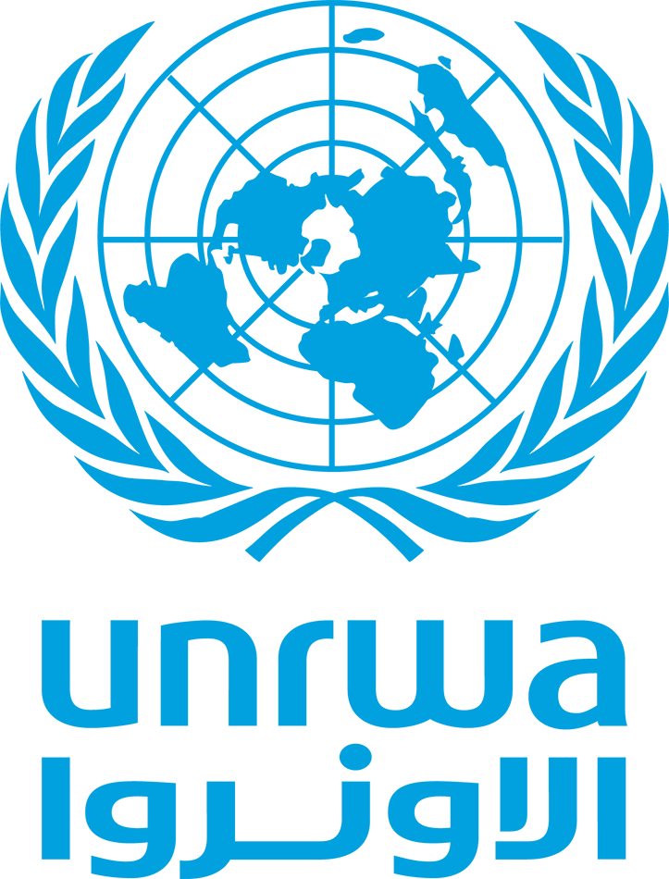
UNRWA
United Nations Relief and Works Agency for Palestine Refugees in the Near East
Relief and Social Services Department – Gaza Field Office

TO WHOM IT MAY CONCERN

Date: 31 May 2026
Ref: RSSD/GFO/2026/Cert

Dear Sir / Madam,

This is to certify that Mr. Ahmed Y. M. AbuAlQumssan, holder of ID No. 801269960, is a registered Palestine refugee with UNRWA under Registration No: 1-02424183.
According to the information and records available, Mr. AbuAlQumssan and his family have been affected by the recent conflict. Their residence was destroyed, resulting in the loss of their home and causing severe hardship and displacement.
As a consequence of these circumstances, Mr. AbuAlQumssan is currently facing significant housing challenges and requires humanitarian support and assistance.
This certificate is issued upon the request of the beneficiary for submission to educational institutions, scholarship providers, humanitarian organizations, or any other relevant entity.
Issued on: 31/05/2026

Please accept our highest consideration and respect.

Field Relief & Social Services Officer UNRWA – Gaza Field Office

